Assignment
Fundamental Theory
(LAB: 4)
NAME: Majid Ali
CMS ID: 053-25-0017
PROGRAM: Software engineering (Section: A)

Question 1:
Length and breadth of a rectangle are 5 and 7 respectively. Write a program to calculate the area and perimeter of the rectangle.
#include<iostream>
using namespace std;
int main(){
int length=5;
int breath=7;
int area=length*breath;
int perimeter=2*(length+breath);
cout<<"Length:"<<length<<endl;
cout<<"breath:"<<breath<<endl;
cout<<"THe area of rectangle is:"<<area<<endl;
cout<<"THe perimeter of rectangle is:"<<perimeter<<endl;
return 0;
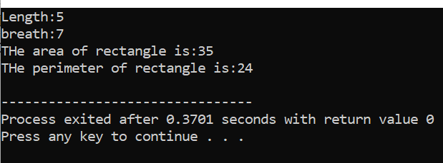
}

Question 2:
Write a program that inputs a six-digit integer, separates the integer into its individual digits and prints the digits vertically using modulus operator. For example, if the user types 953647, the program should print: 9 5 3 6 4 7
9
5
3
6
4
7

#include <iostream>
using namespace std;
int main() {
int num;
cout << "Enter a 6-digit integer: ";
cin >> num;
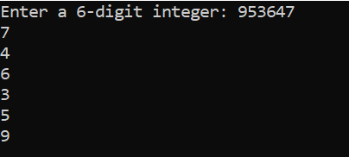
cout << num % 10 << endl;
num = num /10;
cout << num % 10 << endl;
num = num /10;
cout << num % 10 << endl;
num = num /10;
cout << num % 10 << endl;
num = num /10;
cout << num % 10 << endl;
num = num /10;
cout << num % 10 << endl;
return 0;
}
Question 3:
Write a program to convert Fahrenheit into Celsius.
C= 𝟓/𝟗 ( −𝟑𝟐)
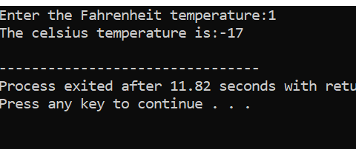
#include<iostream>
using namespace std;
int main(){
float Fahrenheit,celsius;
cout<<"Enter the Fahrenheit temperature:";
cin>>Fahrenheit;
celsius=5.0/9.0*(Fahrenheit-32);
cout<<"The celcius temperature is:"<<celsius<<endl;
return 0;
}

Question 4:
Write a program that finds the value of X by using given formula. Take value of ‘a’ and ‘b’ from user.
C= 2$a^{2}$b (a + $b^{2}$ ) – 3$a^{3}$b
#include<iostream>
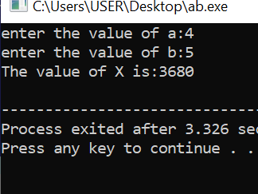
using namespace std;
int main(){
int a,b;
cout<<"enter the value of a:";
cin>>a;
cout<<"enter the value of b:";
cin>>b;
int X=2*(a*a*b)*(a+b*b)-3*(a*a*a*b);
cout<<"The value of X is:"<<X<<endl;
return 0;
}
Question 5:
Create a program to calculate and display the surface of the cylinder given the radius (r) and height (h) using the formula:
s𝒖𝒓𝒇𝒂𝒄𝒆_𝑨𝒓𝒆𝒂 = 𝟐𝝅$r^{2}$+ 𝟐𝝅𝒓𝒉
#include<iostream>
using namespace std;
int main(){
float height,r;
cout<<"enter the value of height:";
cin>>height;
cout<<"enter the value of r:";
cin>>r;
int surface_area=2*(22/7*r*r)+(2*22/7*r*height);
cout<<"The value of surface area is:"<<surface_area<<endl;
return 0;
}

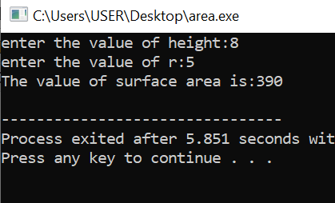
Question 6:
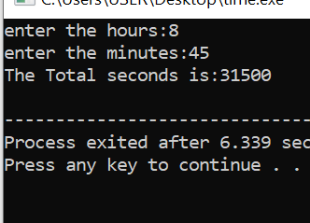
Write a program that takes two values for hours and minutes and then calculates total seconds.
#include<iostream>
using namespace std;
int main(){
int hours,minutes;
cout<<"enter the hours:";
cin>>hours;
cout<<"enter the minutes:";
cin>>minutes;
int Total_seconds=(hours*3600)+(minutes*60);
cout<<"The Total seconds is:"<<Total_seconds<<endl;
return 0;
}
Question 7:
Write a program that takes two numbers from user and checks if the two numbers are equal or not by returning true or false respectively.
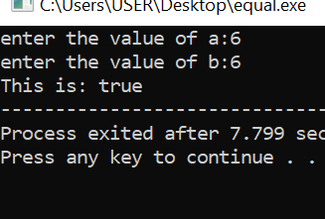
#include<iostream>
using namespace std;
int main(){
int a,b;
cout<<"enter the value of a:";
cin>>a;
cout<<"enter the value of b:";
cin>>b;
cout<<boolalpha<<"This is: "<<(a==b);
return 0;
}

Question 8:
Write a program to enter the values of two variables 'a' and 'b' from user and then check if both the conditions 'a > 50' and 'a < b' are true.
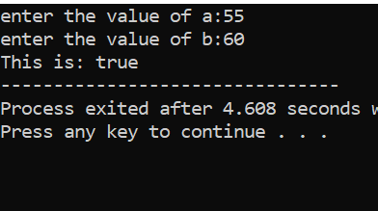
#include<iostream>
using namespace std;
int main(){
int a,b;
cout<<"enter the value of a:";
cin>>a;
cout<<"enter the value of b:";
cin>>b;
cout<<boolalpha<<"This is: "<<(a>50 && a<b);
return 0;
}
Question 9:
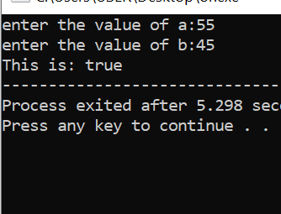
Write a program to enter the values of two variables 'a' and 'b' from user and then check if atleast one of the conditions 'a > 50' and 'a < b' is true.
#include<iostream>
using namespace std;
int main(){
int a,b;
cout<<"enter the value of a:";
cin>>a;
cout<<"enter the value of b:";
cin>>b;
cout<<boolalpha<<"This is: "<<(a>50 || a<b);
return 0;
}

Question 10:
Implement a program that calculates the square of a number entered by the user (using the assignment operator).
#include<iostream>
using namespace std;
int main(){
int num1,num2;
cout<<"enter the value of num1:";
cin>>num1;
cout<<"enter the value of num1:";
cin>>num1;
num2=num1*num1;
cout<<"Square of number is: "<<num2<<endl;
return 0;



